INSERT YOUR LOCAL HEALTH BOARD LOGOHERE



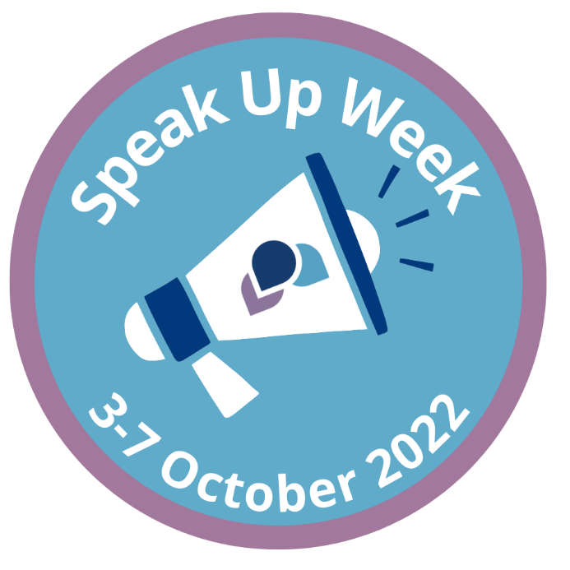

**TAKE PART IN SPEAK UP WEEK!**

INSERT LIST OF EVENTS OR LINK TO A WEBPAGE (OR BOTH) HERE

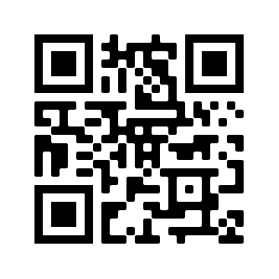

**For more information about the Independent National Whistleblowing Officer please visit our website using the QR code here:**

